ST0249   
AI & Machine Learning

Practical 7  
Introduction to RPA



What you will learn / do in this lab

1. Explore RPA concepts and applications
2. Conduct an RPA experiment

TAble of  
Contents

1. Overview 1

Introduction RPA 1

Applications of RPA 2

2. RPA tool 3

Data Extraction 3

# 1. Overview

In this practical we will be exploring what is Robotic Process Automation (RPA). We will also be running an experiment to use an RPA tool to extract information from the Singapore Polytechnic website.

## Introduction RPA

Robotic process automation (RPA) is the application of technology that allows employees in a company to configure computer software or a “robot” to capture and interpret existing applications for processing a transaction, manipulating data, triggering responses and communicating with other digital systems.

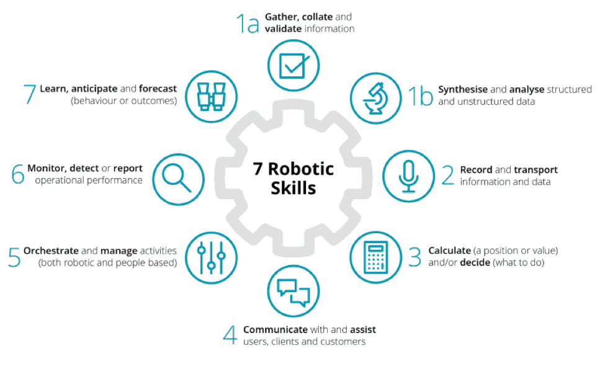

## Applications of RPA

The following are a list of applications for RPA:

* Change of address processing (can be on multiple systems)
* Fraudulent account closing
* Customer complaints processing
* Data cleansing
* Straight-through processing of customer orders
* Order updates
* Shipping notifications

# 2. RPA tool

In the section, we will explore an open source RPA tool.

## RPA Tool Installation

We will be using the TagUI RPA tool available from:

<https://github.com/kelaberetiv/TagUI>

The installation is essential download and unzip into a folder (e.g. c:\tagui).

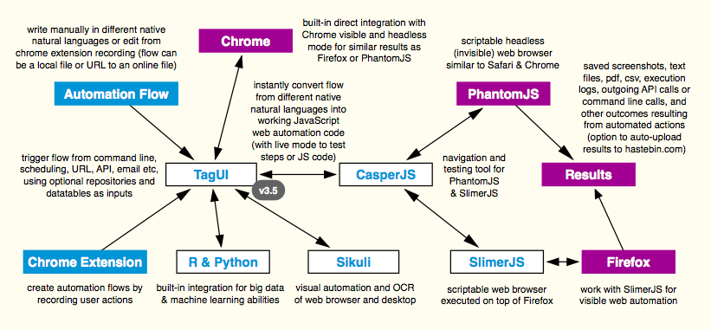

**Figure 1 TagUI Automation Workflow (Cheatsheet)**

## Data Extraction

Following automation flow samples ([tagui/src/samples folder](https://github.com/kelaberetiv/TagUI/tree/master/src/samples)) are included with TagUI.

| **Flow Sample** | **Purpose** | **Comment** |
| --- | --- | --- |
| [1_yahoo](https://github.com/kelaberetiv/TagUI/blob/master/src/samples/1_yahoo) | searches github on Yahoo and captures screenshot of results | (Look at this example for this experiment) |
| [2_twitter](https://github.com/kelaberetiv/TagUI/blob/master/src/samples/2_twitter) | goes to a Twitter page and saves some profile information |  |
| [3_github](https://github.com/kelaberetiv/TagUI/blob/master/src/samples/3_github) | goes to a GitHub page and downloads the repository file |  |
| [4_conditions](https://github.com/kelaberetiv/TagUI/blob/master/src/samples/4_conditions) | goes through examples of using conditions in natural language |  |
| [5_repositories](https://github.com/kelaberetiv/TagUI/blob/master/src/samples/5_repositories) | shows using repositories on Russian social media site VK.com |  |
| [6_datatables](https://github.com/kelaberetiv/TagUI/tree/master/src/samples/6_datatables) | set of flows uses datatables to retrieve and act on GitHub info |  |
| [7_testing](https://github.com/kelaberetiv/TagUI/blob/master/src/samples/7_testing) | shows how to use check step assertions for CI/CD integration |  |
| [8_hastebin](https://github.com/kelaberetiv/TagUI/blob/master/src/samples/8_hastebin) | used by upload option to upload flow result to hastebin.com |  |
| [9_misc](https://github.com/kelaberetiv/TagUI/blob/master/src/samples/9_misc) | shows how to use steps popup, frame, dom, js, { and } block |  |
| [a_facedetect](https://github.com/kelaberetiv/TagUI/blob/master/src/samples/a_facedetect) | uses face recognition to detect profile images on webpages |  |

**Tasks to perform for this experiment**

* Go to the school website for courses
* Extract information on all modules taken by DISM students
* Save snapshot into dism_modules.pdf
* Save the data into the file dism_modules.txt
* Extract information on all modules taken by DIT students
* Save snapshot into dit_modules.pdf
* Save the data into the file dit_modules.txt